**MAJOR FESTIVALS IN CHIDAMBARAM TEMPLE**

South India is a land of festivals with varied traditions and cultures. Each and every festival in South India has a long history and unique origin, which enhances its value and tremendous importance. Being religious or secular in nature, every South Indian Festival has a deep meaning, often connected with the lessons of life and happiness. Dravidian tradition is followed and most of the festivals are based on mythology and seasonal changes. People participate in these festivals whole heartedly.

In Chidambaram temple worship is practiced through various annual and season festivals which will be explained in detail. Apart from these six daily poojas are performed and six anointing ceremonies are performed for Lord Nataraja in a year. Lord Nataraja is given six abhishekams in a year.

Brahmotsavam, Ani Thirumanjanam, Thai Poosam, and Arudra Dharshan are some of the temple festivals that attract large crowds from far and nearby places.

The two important annual festivals dedicated to Lord Nataraja are Arudhra Darisanam and Aani Thirumanjanam

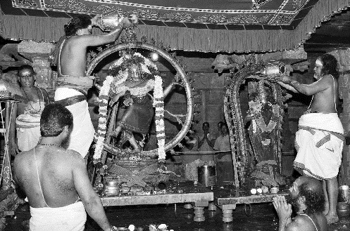**Thiruvathira or Thiruvathirai or Arudhra Darisanam:**

Thiruvathirai(Arudhra) in Tamil means the “sacred wave” using which the universe was created by Lord Shiva. In Chidambaram temple it is a ten-day festival. It takes place on the full moon night in the Tamil month of Margazhi(around December- January). Unmarried women keep a fast during daytime and moon rise ends this fast. the icons of Shri Nataraja and Shivakama Sundari are decorated with flowers and taken around the town to the accompaniment of nadaswaram. On the last day of this festival Maha Abhishekam is done to Lord Nataraja, which is the Hindu ritual of pouring water or other sacred substances on a statue of a deity while also chanting mantras and it is believed that by bathing the statue, or murti, the devotees cleanse and purify their own minds. These sacred substances include milk, yogurt, ghee, honey, sugar, oil and fruit juices, among others. The first five of these represent the five elements of water, earth, fire, air and ether.  the devotees ask the deity to purify those elements within themselves as well as the corresponding five senses: vision (water), taste (earth), hearing (fire), smell (ether) and touch (air). In the day time, chariot procession takes place. The cosmic dance of Lord Shiva is enacted on this day.

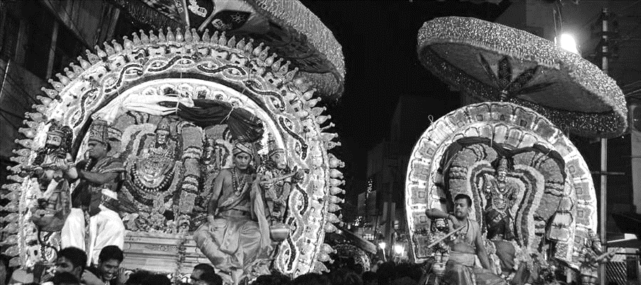**Aani Thirumanjanam:**

It is also a 10-day festival and is celebrated around the months on June-July. The word "Thirumanjanam" means **Holy bath.** It is believed that Lord Nataraja gives darshan to his devotees in the months Aani and Margazhi and an Abhishekam is performed for Lord Nataraja on the last day (10th day). This festival is believed to correspond to the period of ‘between two’ which highlights the transition from day to night, the moment called ‘pradosha’. After this day the nights are longer than days and the last day of Arudhra Darisanam festival is the longest night of the year. Scriptures say it was on Ani Uthiram, under a kurundai tree, that the Lord offered upadesa to Sage Manikkavachaka the writer of the famous Thiruvachakam. Legends have it that during the abhishekam to the Lord, as everyone watched, the sage merged in the Lord as a brilliant flame.there is a flag hoisting ceremony in the early morning, the official start of the festival. the 9th day is the great day of the Chariot Festival. Lord Nataraja and Mother Parvati are carried from the Golden Sabha to the pavilion in the East Car street where the chariots are waiting and are pulled by devotees. The procession is a wonderful divine experience for all. After returning to the starting point in the late afternoon puja. Local dancers perform in front of the ratham. They believe that lord natraja is their ultimate guru. Thousands of devotees gather at Chidambaram every year to witness the grandeur celebrations of this venerated festival.

**Chidambaram Natyanjali Festival:**

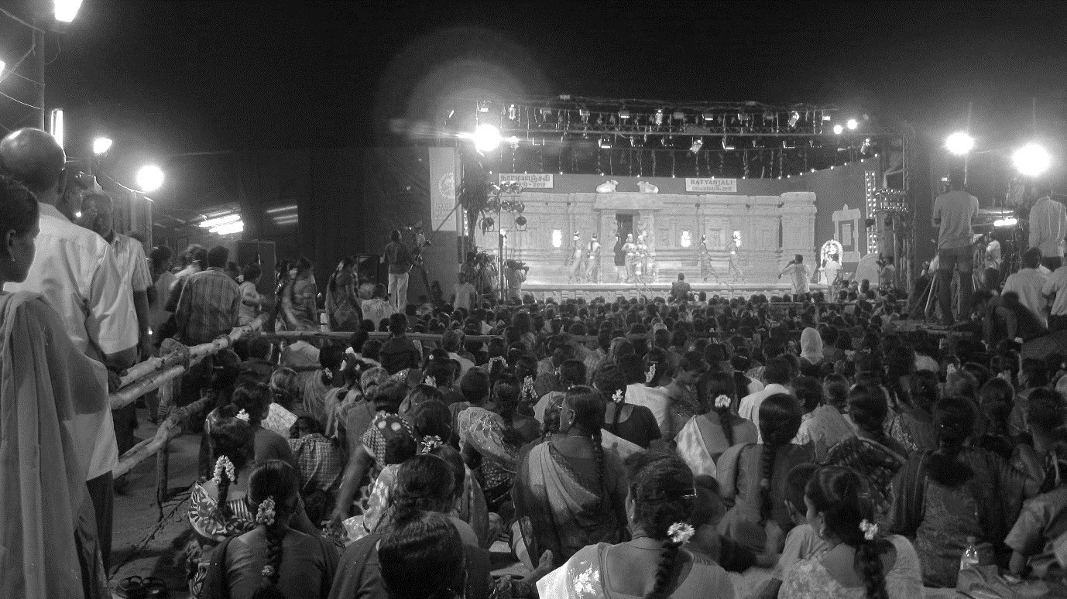

The dance festival of natyanjali is held for five days during February(around shivratri) organised jointly by the Government of Tamil Nadu, The Department of Tourism, Government of India, The Ministry of Tourism and The Natyanjali Trust of Chidambaram. This festival was introduced at the temple of Chidambaram.  After that it is celebrated in different place like Chennai, Thanjavur, Mayavaram, Thirunallar etc. its is an annual festival where different kind of Indian classical dance forms are performed. The dance avenue is the enclosure beyond the gopurams to facilitate closure of temple in time and accommodate a larger audience. The number of dance performers has been increasing year after year. The performance starts from 6.30 PM on the festival days and continues past midnight. These mesmerizing dances are as old as this mankind and will prevail till dooms day. The lord of dance, the peerless cosmic dancer Lord Nataraja is believed to be the originator of Bharatanatyam, one of the revered, exquisite dances of India. Without a Bharatanatyam performance temple function ends, it is a ritual that if we pay our tribute to God through dance, He will be pleased and shower his blessings on his devotees. it is blessing for the performers to perform on that stage in front of the Lord Shiva. This festival falls in the eve of Maha Shivaratri. We come to know about ancient lore, mythologies and customs through these variety of dance forms. This festival is a perfect blend of Indian culture, performing art and devotion of God.